**• Connect to the Store Sales Data and do the following: - −**

**Remove all the blank rows. –**

**Update the column header if they are not updated –**

***OrderTable(Header Updated,Removed Null values)***

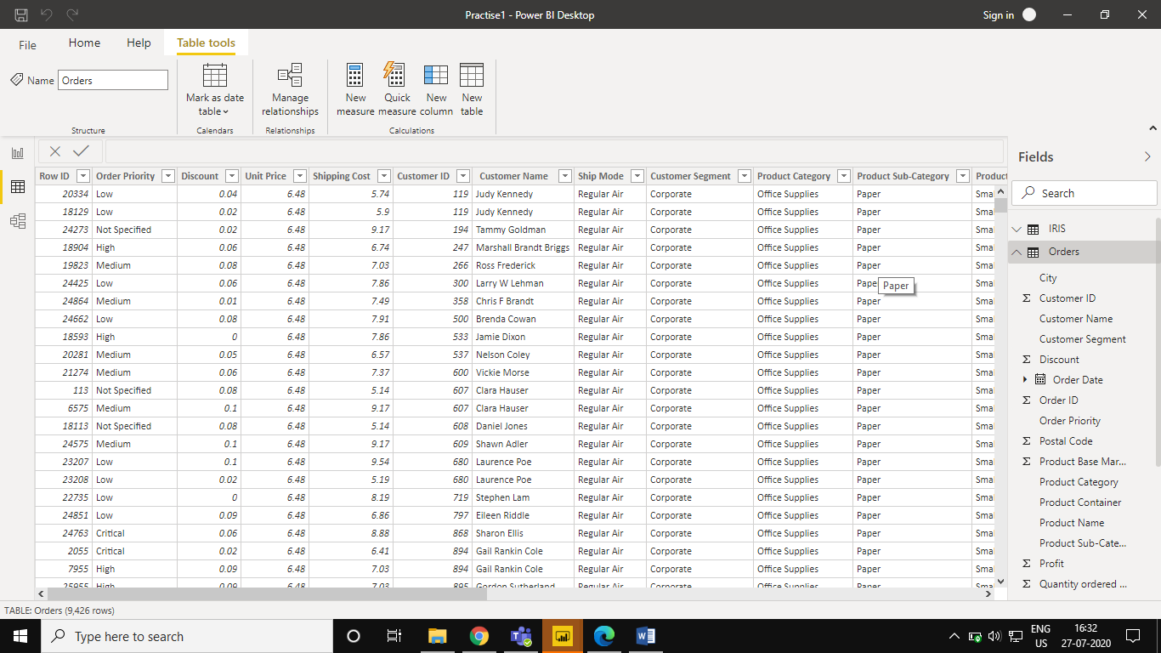

***ReturnsTable(Header Updated,Removed Null values)***

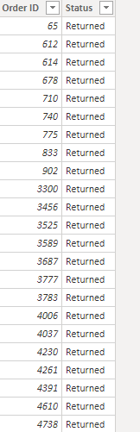

***UserTable(Header Updated,Removed Null values)***

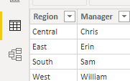

***Create a text table and show the sales in terms of***

***o Customers***

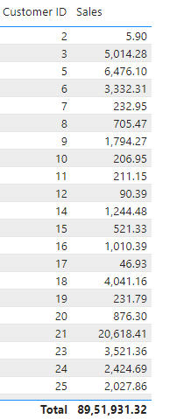

***o Product Category***

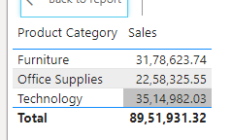

***o Regions***

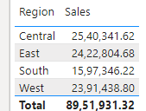

***Create a Donut Chart showing sales in terms of Product category***

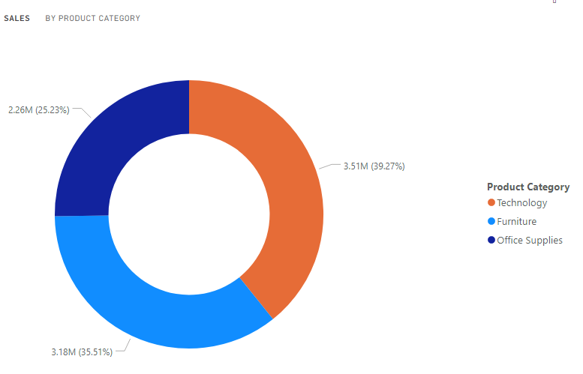

***Create a line and Clustered Column Chart showing the Sales and Discount as per the State or Province***

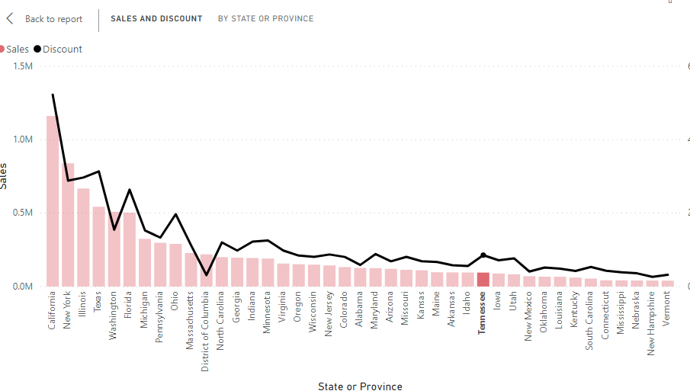

***NewYork has highest sales for Technology Category***

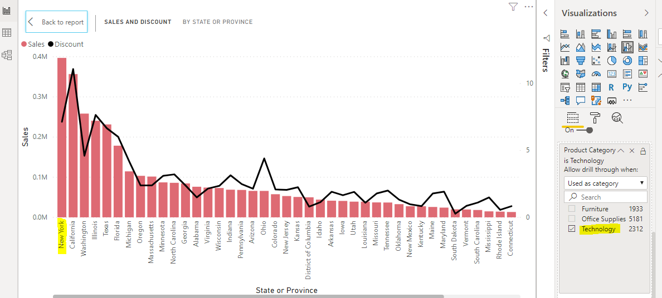

***Region as Slicer***

